Recoding Variables in SPSS
The instructions below will show you how to recode variables in SPSS 14.0. You can use recoding to produce different values or codes for a variable. Recoding can be done in one of two ways:
- Recoding into the same variable
- Recoding into a different variable
In this guide we will concentrate on recoding into a different variable for which there are 3 main types of recoding:
- Recode single values
- Recode a given range of values
- Recode data into two categories
We will use an example of each type in order to demonstrate how to recode variables in SPSS.
Recode single values
Example: The data given below represents runs scored by 5 batsmen in a national-level match. Recode the data so that the batsmen are rank ordered by their number of runs, with the batsman with the highest runs given a code of "1" and the batsman with the lowest runs given a "5".
Number of runs by batsmen
Batsmen | 1 | 2 | 3 | 4 | 5
Runs | 86 | 120 | 56 | 10 | 18
- Enter the data in the SPSS Data Editor and name the variable "Runs".
Remember that each individual's results go on a separate line (row) in SPSS.
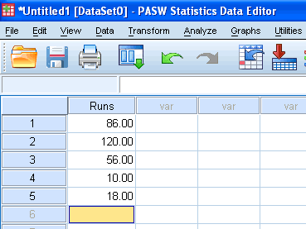
Published with written permission from SPSS Inc, an IBM Company.
- Click on Transform > Recode Into Different Variables... in the top menu.
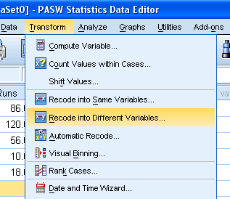
Published with written permission from SPSS Inc, an IBM Company.
- You need to highlight the "Runs" variable in the left-hand box by clicking on it and then click the button to move it across to the "Numeric Variable -> Output Variable:" box.
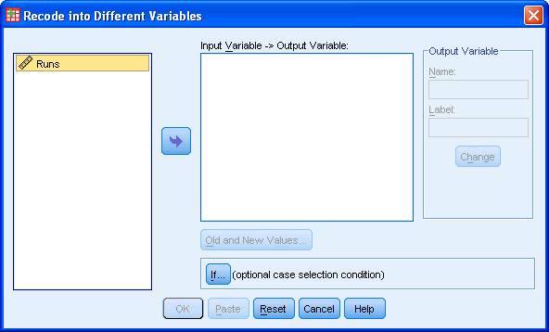
Published with written permission from SPSS Inc, an IBM Company.
- In the Output Variable grouping show below, give the new variable you are about to create a name and label. In this example, we have named the new variable "Ranked-Runs" and the label as "Ranked Runs" (see the ).
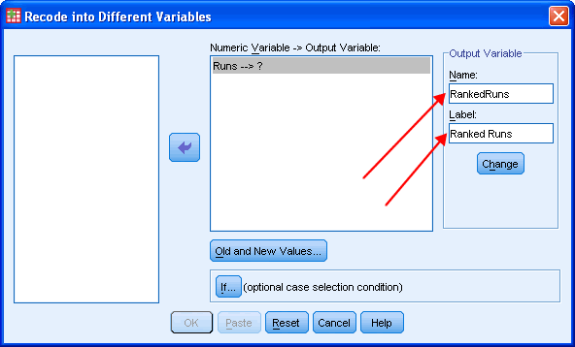
Published with written permission from SPSS Inc, an IBM Company.
- Click the button.
- You should now see that the "Numeric Variable -> Output Variable:" box has now changed to reflect these changes (see the ).
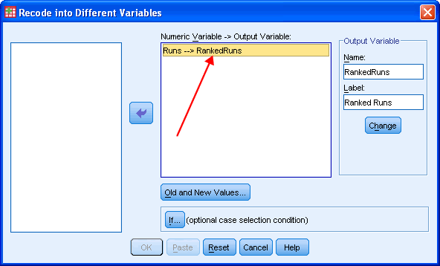
Published with written permission from SPSS Inc, an IBM Company.
- Click the button.
- Enter the first score (120) into the "Old Value" box and set the new code of "1" into the "New Value".
- Click the button.
- Repeat for all other values such that you are presented with the following screen:
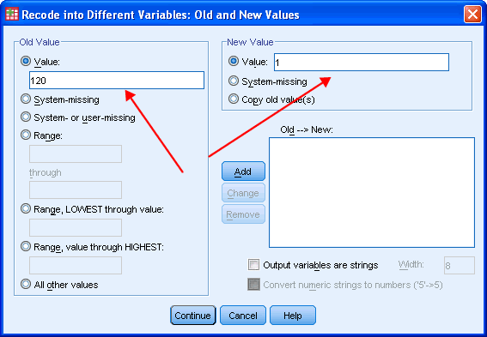
Published with written permission from SPSS Inc, an IBM Company.
- Click the button.
- You will have returned to the previous screen and will now have to click the button. This will take you to the Data View Editor which will now show that you have created a new variable that is based on recoding your existing variable:
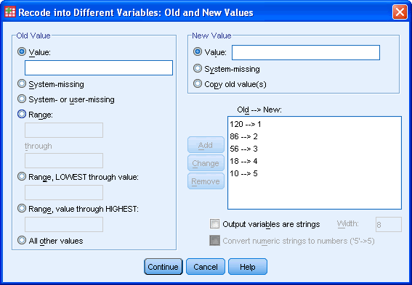
Published with written permission from SPSS Inc, an IBM Company.
Recode a given range
Example: The data given below represents the scores of 10 students in a final examination. Recode the data giving code "1" to scores between 75 - 100, code 2 to scores between 61 - 75, code 3 to scores between 41 - 60 and code 4 to scores between 0 - 40.
Final examination scores of 10 students
Scores | 58 | 86 | 74 | 70 | 79 | 60 | 35 | 42 | 55 | 91
- Enter the data in the SPSS Data Editor and name the variable "Scores".
Remember that each individual's results go on a separate line (row) in SPSS.
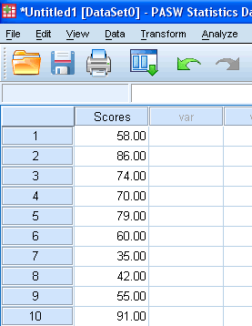
Published with written permission from SPSS Inc, an IBM Company.
- Click on Transform > Recode Into Different Variable... in the top menu.
- Transfer the variable you want to recode by selected it and pressing the button and give the new variable a name and label. In this example, we have given the new variable a name of "NScores" and label of "New Scores" as shown below:
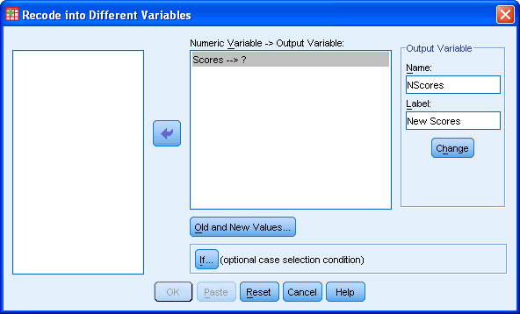
Published with written permission from SPSS Inc, an IBM Company.
- Click on the button.
- Click on the button.
- Enter the first range of "75 - 100" into the "Old Value" box and set the new code to "1" into the "New Value" box as shown below:
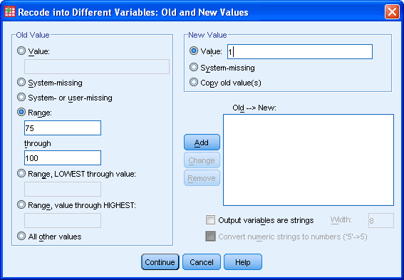
Published with written permission from SPSS Inc, an IBM Company.
- Click on the button.
- Repeat for all other values such that you are presented with the following screen:
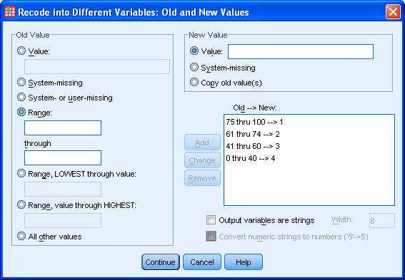
Published with written permission from SPSS Inc, an IBM Company.
- Click the button.
- You will have returned to the previous screen and will now have to click the button. This will take you to the Data View Editor which will now show that you have created a new variable that is based on recoding your existing variable:
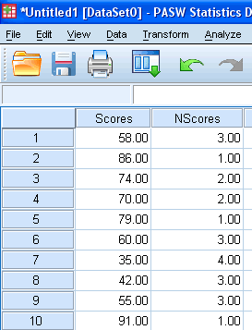
Published with written permission from SPSS Inc, an IBM Company.
Recoding data into two categories
Example: The data given below represents a satisfaction rating out of 10 for a new service offered by a company. The company would like to code all those who responded by giving ratings above 5 a "Satisfactory" code and those below 5 a "Dissatisfactory" code.
Satisfaction scores for a new service
Scores | 3 | 6 | 8 | 9 | 7 | 2 | 10 | 6 | 4 | 8 | 9 | 3
- Enter the data in the SPSS Data Editor and name the variable "Ratings".
Remember that each individual's results go on a separate line (row) in SPSS.
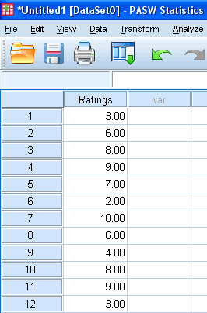
Published with written permission from SPSS Inc, an IBM Company.
- Click on Transform > Recode Into Different Variable... in the top menu.
- Transfer the variable you want to recode by selected it and pressing the button and give the new variable a name and label. In this example, we have given the new variable a name of "NRatings" and label of "New Ratings" as shown below:
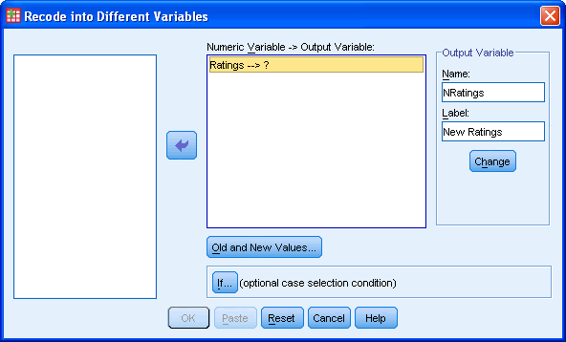
Published with written permission from SPSS Inc, an IBM Company.
- Click the button.
- Click the button.
- Enter the value of "5" into the "Range, LOWEST through value:" box and set the new code to "1" into the "New Value" box. Click the "Output variables are strings" checkbox so that it will except values that are not numbers. You need to increase the "Width:" from 8 to 16 also, so that the string labels are not truncated.
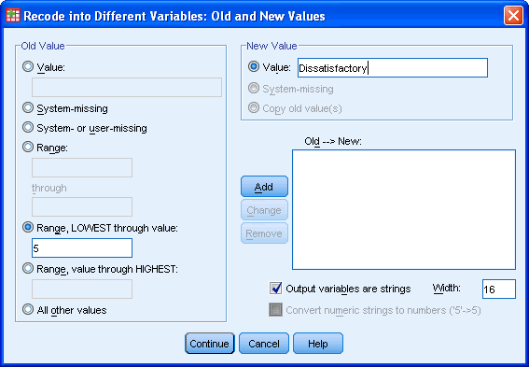
Published with written permission from SPSS Inc, an IBM Company.
- Click the button.
- Enter the value of "6" into the "Range, value through HIGHEST:" box and set the new code to "1" into the "New Value" box.
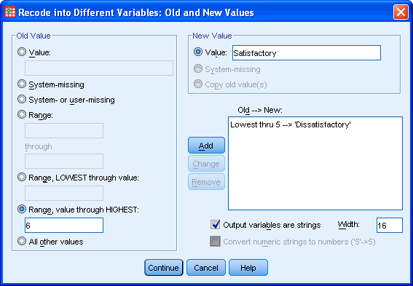
Published with written permission from SPSS Inc, an IBM Company.
- Click the button.
- Click the button.
- You will have returned to the previous screen and will now have to click the button. This will take you to the Data View Editor which will now show that you have created a new variable that is based on recoding your existing variable:
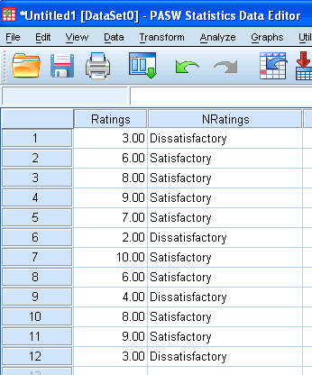
Published with written permission from SPSS Inc, an IBM Company.

