Spearman's Rank Order Correlation using SPSS
Objectives
The Spearman Rank Order Correlation coefficient, r_{s}, is a non-parametric measure of the strength and direction of association that exists between two variables measured on at least an ordinal scale. It is denoted by the symbol r_{s} (or the greek letter ,pronounced rho). The test is used for either ordinal variables or for interval data that has failed the assumptions necessary for conducting the Pearson's product-moment correlation. If you would like some more background on this test you can find it in our statistical guide here.
Assumptions
- Variables are measured on an ordinal, interval or ratio scale (see out Types of Variable article).
- Variables need NOT be normally distributed.
- There is a monotonic relationship between the two variables, i.e. either the variables increase in value together or as one variable value increases the other variable value decreases (see guide here for more information).
- This type of correlation is NOT very sensitive to outliers.
Example
A teacher is interested in those who do the best at English also do better in Maths (assessed by exam) students in English are also the best performers in Maths. She records the scores of her 10 students as they performed in end-of-year examinations for both English and Maths.
Test Procedure in SPSS
- Click Analyze > Correlate > Bivariate... on the menu system as shown below:
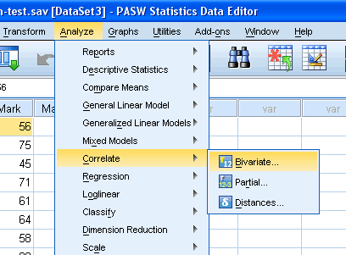
Published with written permission from SPSS Inc, an IBM Company.
- Transfer the variables "English_Mark" and "Maths_Mark" into the "Variables" box by dragging-and-dropping or by clicking the button. You will end up with a screen similar to the one below:
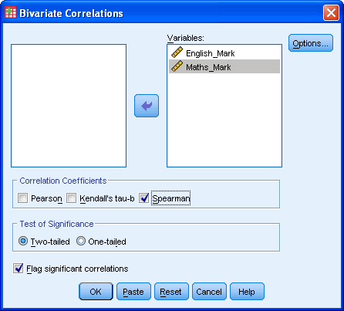
Published with written permission from SPSS Inc, an IBM Company.
- Make sure that you uncheck the Pearson tickbox (it is selected by default in SPSS) and check the Spearman tickbox under the "Correlation Coefficients" group.
- Click the button.
Output
You will be presented with 3 tables in output viewer under the title "Correlations" as below:
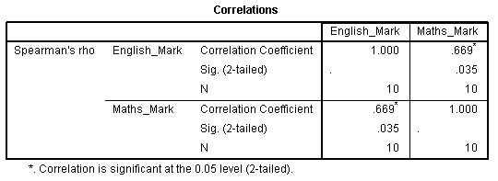
Published with written permission from SPSS Inc, an IBM Company.
The results are presented in a matrix such that, as can be seen, the correlations are replicated. Nevertheless, the table presents Spearman's Rank Order Correlation, its significance value and the sample size that the calculation was based on. In this example, we can see that Spearman's correlation coefficient, r_{s}, is 0.669 and that this is statistically significant (P = 0.035).
Reporting the Output
In our example you might present the results are follows: A Spearman's Rank Order correlation was run to determine the relationship between 10 students' English and maths exam marks. There was a strong, positive correlation between English and maths marks, which was statistically significant (r_{s}(8) = .669, P = .035)

