Ranking Data in SPSS
Ranking is used to recode the data into their rank ordering from smallest to largest or largest to smallest. We will demonstrate this by entering in some data and ranking it in SPSS.
Data to Rank
87 | 26 | 54 | 39 | 67 | 12 | 28 | 98 | 54 | 68 | 23 | 64 | 28 | 43 | 77
- Your data should end up looking like the following (we have named the variable "Data"):
Remember that each individual's results go on a separate line (row) in SPSS.
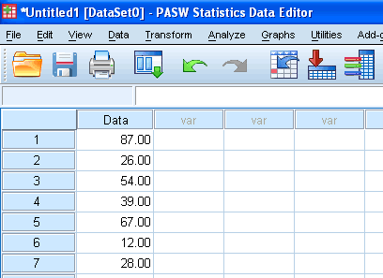
Published with written permission from SPSS Inc, an IBM Company.
- Click on Transform > Rank Cases... in the top menu.
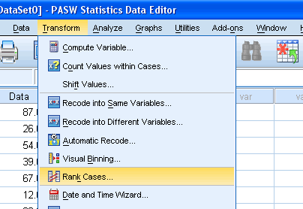
Published with written permission from SPSS Inc, an IBM Company.
- Click on the Data variable in the lefthand box and click the button to move it to the "Variable(s):" box.
Uncheck the "Display summary tables" checkbox.
If you wish to have the largest value have a rank of "1" then select the radio box "Largest value" from the "Assign Rank 1 to" box. We will stick with the default in this example, which is "Smallest value".
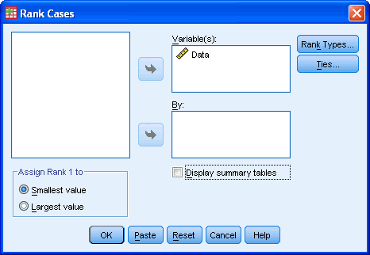
Published with written permission from SPSS Inc, an IBM Company.
- Click on the button.
- You will be presented with the SPSS Data Editor which will now show the ranked data under a new variable name. This new variable name will have the same variable name as the old name but with the addition of the letter "R" at the beginning. Hence, in this case, the ranked data variable is called "RData".
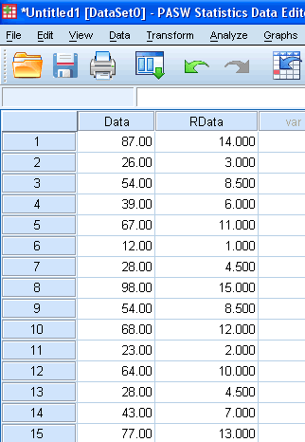
Published with written permission from SPSS Inc, an IBM Company.

