Pearson's Product-Moment Correlation using SPSS
Objectives
The Pearson product-moment correlation coefficient is a measure of the strength and direction of association that exists between two variables measured on at least an interval scale. It is denoted by the symbol r. An introductory guide to this test is provided in our Statistical Guides section here and we recommend you read it if you are not familiar with this test.
Assumptions
- Variables are measured at the interval or ratio level (continuous) (see Types of Variable guide).
- Variables are approximately normally distributed (see Testing for Normality guide).
- There is a linear relationship between the two variables.
- Pearsons's r is sensitive to outliers so it is best if outliers are kept to a minimum or there are no outliers.
Example
A researcher wishes to know whether a person's height is related to how well they perform in a long jump. The researcher recruits untrained individuals from the general population, measures their height and gets them to perform a long jump. They then go about investigating whether there is an association between height and long jump performance.
Testing assumptions
Your variables need to be normally distributed. To determine whether your samples are normally distributed read our guide on Testing for Normality in SPSS. Pearson's r is also very susceptible to outliers in the data so you need to test for outliers. What if your samples are not normally distributed or there are outliers? If your samples violate the assumption of normality or have outliers then you might need to consider using a non-parametric test such as Spearman's Correlation.
Test Procedure in SPSS
- Click Analyze > Correlate > Bivariate... on the menu system as shown below:
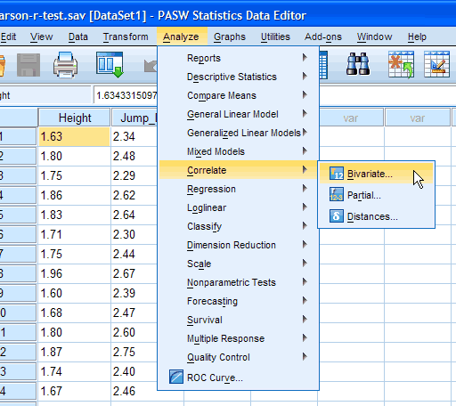
Published with written permission from SPSS Inc, an IBM Company.
You will be presented with the following screen:
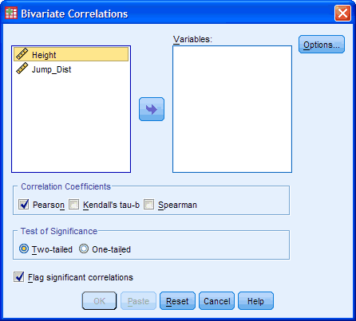
Published with written permission from SPSS Inc, an IBM Company.
- Transfer the variables "Height" and "Jump_Dist" into the "Variables:" box by dragging-and-dropping or by clicking the button. You will end up with a screen similar to the one below:
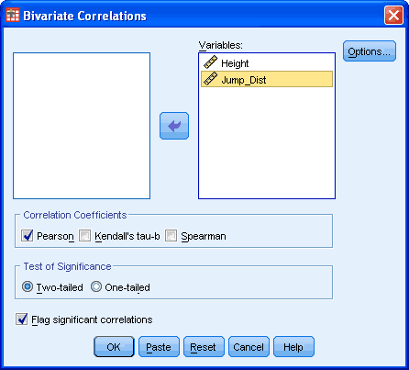
Published with written permission from SPSS Inc, an IBM Company.
- Make sure that the Pearson tickbox is checked under the "Correlation Coefficients" group (although it is selected by default in SPSS).
- Click the button. If you wish to generate some descriptives you can do it here by clicking on the particular tickbox.
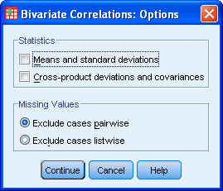
Published with written permission from SPSS Inc, an IBM Company.
Then click the button.
- Click the button.
Output
You will be presented with the Correlations table in the output viewer as below:
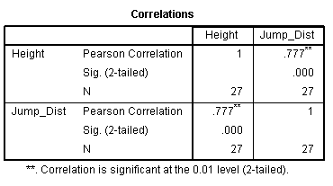
Published with written permission from SPSS Inc, an IBM Company.
The results are presented in a matrix such that, as can be seen above, the correlations are replicated. Nevertheless, the table presents the Pearson correlation coefficient, the significance value and the sample size that the calculation is based on. In this example we can see that the Pearson correlation coefficient, r, is 0.777 and that this is statistically significant (P < 0.0005).
Understanding the Output
In our example you might present the results are follows:
A Pearson product-moment correlation was run to determine the relationship between an individual's height and their performance in a long jump (distance jumped). The data showed no violation of normality, linearity or homoscedasticity. There was a strong, positive correlation between height and distance jumped, which was statistically significant (r = .777, n = 27, P < .0005).

