ndependent T-Test using SPSS
Objectives
The independent t-test compares the means between two unrelated groups on the same continuous, dependent variable. The SPSS t-test procedure allows the testing of equality of variances (Levene's test) and the t-value for both equal- and unequal-variance. It also provides the relevant descriptive statistics. A statistical guide on the independent t-test is provided here.
Assumptions
- Independent variable consists of two independent groups.
- Dependent variable is either interval or ratio (see our guide on Types of Variable).
- Dependent variable is approximately normally distributed (see Testing for Normality article)
- Similiar variances between the two groups (homogeneity of variances) (tested for in this t-test procedure).
Background to Example
The concentration of cholesterol (a type of fat) in the blood is associated with the risk of developing heart disease, such that higher concentrations of cholesterol indicate a higher level of risk and lower concentrations indicate a lower level of risk. If you lower the concentration of cholesterol in the blood then your risk for developing heart disease can be reduced. Being overweight and/or physically inactive increases the concentration of cholesterol in your blood. Both exercise and weightloss can reduce cholesterol concentration. However, it is not known whether exercise or weightloss is best for lowering blood cholesterol concentration.
Example
A random sample of inactive male individuals that were classified as overweight were recruited to a study to investigate whether an exercise or weight loss intervention is more effective in lowering cholesterol levels. To this end, they randomly split the group into two sub-groups; one group underwent an exercise training programme and the other group undertook a calorie-controlled diet. In order to determine which treatment programme was more effective, the mean cholesterol concentrations were compared between the two groups at the end of the treatment programmes.
Setup in SPSS
In SPSS we separated the groups for analysis by creating a grouping variable called "Group" and gave the exercise group a value of "1" and the diet group a value of "2". Cholesterol concentrations were entered under the variable name "Cholesterol". How to correctly enter data in SPSS to run an independent t-test is explained in our guide here.
Descriptives
Unless you have other reasons to do so, it would be considered normal to present information on the mean and standard deviation for this data. You might also state the number of participants you had in each group that were to be analysed. This is in case you have, for example, missing values and the number of recruited participants is larger than that which can be analysed.
You might also wish to present a diagram so that you can show your results visually in order that a reader might understand them better. You could present a bar chart with error bars (for example, SD or 95% CI) (see our guide here).
Testing assumptions
To determine whether your samples are normally distributed read our Testing for Normality article. What if your samples are not normally distributed? Well, if your data set is large then small deviations are generally tolerable. However, if your samples are small or your data set is largely non-normal then you need to consider a non-parametric test instead, such as the Mann-Whitney U Test.
The assumption of equal variances is tested in SPSS by Levene's Test for Equality of Variances. The result of this test is presented in the output when running an independent t-test and is discussed later in this guide.
Test Procedure in SPSS
- Click Analyze > Compare Means > Independent-Samples T Test... on the top menu as shown below.
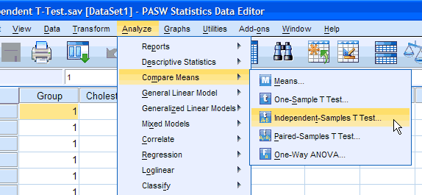
Published with written permission from SPSS Inc, an IBM company.
You will be presented with the following:
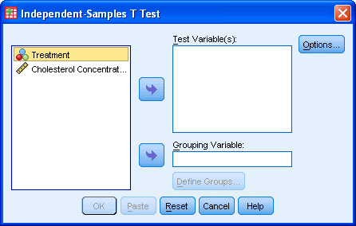
Published with written permission from SPSS Inc, an IBM company.
- Put the "Cholesterol Concentration" variable into the "Test Variable(s):" box and the "Treatment" variable into the "Grouping Variable:" box by highlighting the relevant variables and pressing the buttons.
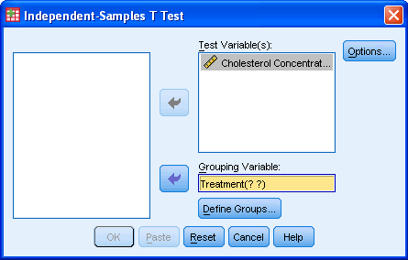
Published with written permission from SPSS Inc, an IBM company.
- You then need to define the groups (treatments). Press the button.
You will be presented with the following screen:
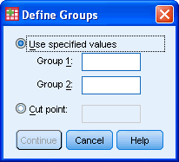
Published with written permission from SPSS Inc, an IBM company.
- Enter "1" into the "Group 1:" box and enter "2" into the "Group 2:" box. Remember that we labelled the Diet Treatment group as "1" and the Exercise Treatment group as "2". If you have more than 2 treatment groups, e.g. a diet, exercise and drug treatment group, then you could type in "1" to "Group 1:" box and "3" to "Group 2:" box if you wished to compare the diet with drug treatment.
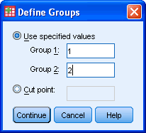
Published with written permission from SPSS Inc, an IBM company.
- Press the button
- If you need to change the confidence level limits, or change how to exclude cases then press the button.
You will be presented with the following:
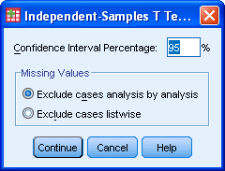
Published with written permission from SPSS Inc, an IBM company.
- Click the button.
- Click the button.
Output of the independent t-test in SPSS
You will be presented with two tables containing all the data generated by the Independent t-test procedure in SPSS.
Group Statistics Table
This table provides useful descriptive statistics for the two groups that you compared including the mean and standard deviation.
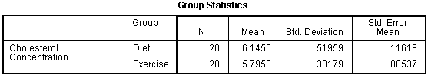
Published with written permission from SPSS Inc, an IBM company.
Independent Samples Test Table
This table provides the actual results from the independent t-test and Levine's Test for Equality of Variances. [In order to fit the image of this table onto this webpage we have swapped the rows and columns in the table so that the table is arranged vertically not horizontally. Therefore, you will be presented with a slightly differently looking table but the data and interpretation remain the same. By clicking on the image below you will see the original, horizontally arranged table so that you are able to compare the two.]
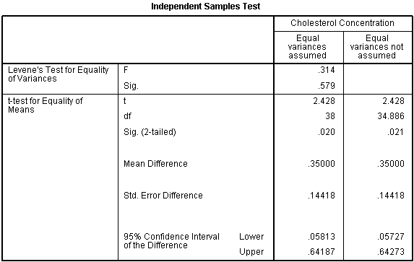
Published with written permission from SPSS Inc, an IBM company.
The first thing you need to do is check to see if you have similar variances in the two groups by checking the result of Levine's Test for Equality of Variances. To check this, look at the "Sig." row within Levine's Test for Equality of Variances row as highlighted below:
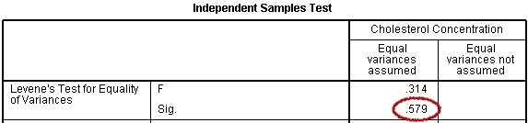
Published with written permission from SPSS Inc, an IBM company.
If the variances are equal in both groups then the P-value ("Sig.") will be greater than 0.05. However, if the "Sig." value is less than 0.05, the variances are unequal. If you have unequal variances then you need to use the Equal variances not assumed column otherwise you use the Equal variances assumed column.
In this case, we have a P-value of 0.579 for Levene's test so we can conclude that we have equal variance and we look at the Equal variances assumed column. Looking down this column we can see that the group means are significantly different as the value in the "Sig. (2-tailed)" row is less than 0.05. Looking at the Group Statistics table we can see that those people that undertook the exercise trial had lower cholesterol levels at the end of the programme than those that underwent a calorie-controlled diet.
Reporting the output of the independent t-test
We might report the statistics in the following format: t(degrees of freedom[df]) = t-value, P = significance level. In our case this would be: t(38) = 2.470, P = 0.018. Therefore, we might report the results of the study as follows:
This study found that overweight and physically inactive male participants had statistically significant lower cholesterol levels (5.78 ± 0.38 mmol/L) at the end of an exercise training programme vs. after a calorie-controlled diet (6.21 ± 0.65 mmol/L) (t(38) = 2.470, P = 0.018).

