Dependent T-Test using SPSS
Objectives
The dependent t-test (called the Paired-Samples T Test in SPSS) compares the means between two related groups on the same continuous variable. The SPSS t-test procedure also provides relevant descriptive statistics. For an easy-to-follow guide on the dependent t-test please see our statistical guide.
Assumptions
- Dependent variable is interval or ratio (continuous) (see our Types of Variable guide).
- The differences between the two groups on the dependent t-test approximately normally distributed (see Testing for Normality article).
- Independent variable consists of one group or two "matched-pairs" groups.
Example
A group of Sports Science students (n = 20) are selected from the population to investigate whether a 12 week plyometric training programme improves their standing long jump performance. In order to test whether this training improves performance, the sample group are tested for their long jump performance, undertake a plyometric training programme, and then measured again at the end of the programme.
Testing assumptions
To determine whether your samples are normally distributed read our Testing for Normality article. What if your samples are not normally distributed? Well, if your data set is large then small deviations are generally tolerable. However, if your samples are small or your data set is largely non-normal then you need to consider a non-parametric test instead, such as the Wilcoxon Signed-Rank Test.
Test Procedure in SPSS
[If you are unsure of how to correctly enter your data into SPSS in order to run a dependent t-test then read our guide on how to do it here.]
- Click Analyze > Compare Means > Paired-Samples T Test... on the top menu.
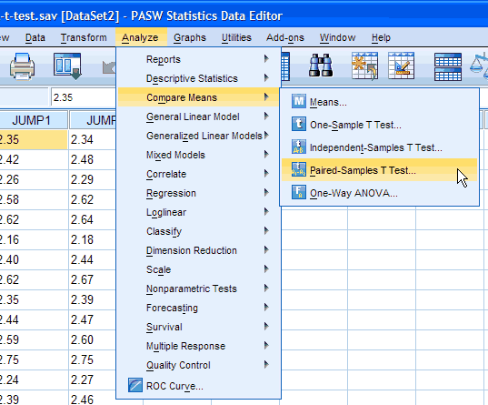
Published with written permission from SPSS Inc, an IBM company.
- You will be presented with the following:
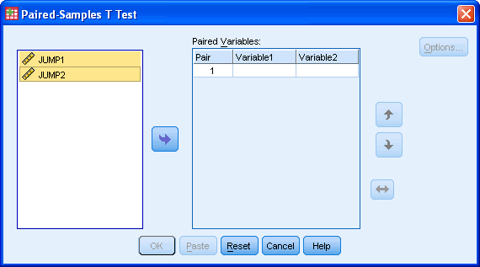
Published with written permission from SPSS Inc, an IBM company.
- You need to transfer the variables "JUMP1" and "JUMP2" into the "Paired Variables:" box. There are two ways to do this. You can either highlight both variables (use the cursor and hold down the shift key and press the button or you can drag and drop each variable into the boxes) If you are using older versions of SPSS, you will need to transfer the variables using the former method.
You will end up with a screen similar to the one below:
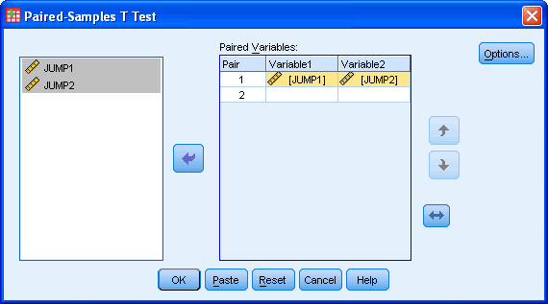
Published with written permission from SPSS Inc, an IBM company.
button shifts the pair of variables you have highlighted down one level.
button shifts the pair of variables you have highlighted up one level.
button shifts the order of the variables with a variable pair itself.
- If you need to change the confidence level limits or to exclude cases then press the button:
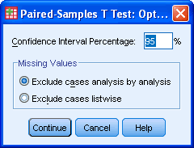
Published with written permission from SPSS Inc, an IBM company.
Click on the button.
- Click the button to generate the output.
SPSS Output of the Dependent T-Test
You will be presented with 3 tables in the output viewer under the title "T-Test" but you only need to look at two tables - Paired Sample Statistics Table and the Paired Samples Test table
Paired Sample Statistics Table
The first table titled Paired Sample Statistics is where SPSS has generated descriptive statistics for your variables. You can use the data here to describe the characteristics of the first and second jumps in your results.
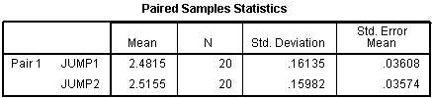
Published with written permission from SPSS Inc, an IBM company.
The second table titled Paired Samples Correlations provides you with the correlation between "JUMP1" and "JUMP2".
Paired Samples Test Table
The third table titled Paired Samples Test is the table where the results of the dependent t-test are presented. A lot of information is presented here and it is important to remember that this information refers to differences between the two jumps (the subtitle reads "Paired Differences"). As such, the columns of the table labelled "Mean", "Std. Deviation", "Std. Error Mean", 95% CI refer to the mean difference between the two jumps and the standard deviation, standard error and 95% CI of this difference, respectively. The last 3 columns express the results of the dependent t-test, namely the t-value, the degrees of freedom and the significance level.
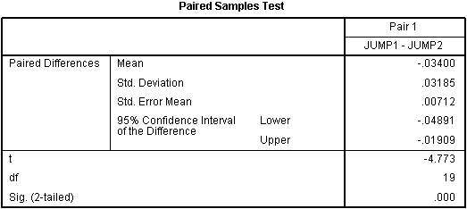
Published with written permission from SPSS Inc, an IBM company.
Reporting the output of the Dependent T-Test
We might report the statistics in the following format: t(degrees of freedom[df]) = t-value, P = significance level. In our case this would be: t(19) = -4.773, P < 0.0005. Due to the means of the two jumps and the direction of the t-value we can conclude that there was a statistically significant improvement in jump distance following the plyometric training programme from 2.48 ± 0.16 m to 2.52 ± 0.16 m (P < 0.0005); an improvement of 0.03 ± 0.03 m.
N.B. SPSS will output many results to many decimal places but you should understand your measuring scale to know whether it is appropriate to report your results in such accuracy.

