Chi-Square Test for Association using SPSS
Objective
The Chi-Square test for independence, also called Pearson's Chi-square test or the Chi-square test of association is used to discover if there is a relationship between two categorical variables.
Example
Educators are always looking for novel ways in which to teach statistics to undergraduates as part of a non-statistics degree course, e.g. psychology. With current technology it is possible to present how-to guides for statistical programs online instead of in a book. However, different people learn in different ways. An educator would like to know whether gender (male/female) is associated with the preferred type of learning medium (online vs. books). We therefore have two nominal variables: Gender(male/female) and Preferred Learning Medium (online/books).
Assumptions
- Two variables that are ordinal or nominal (categorical data). (see our guide on Types of Variable)
- There are two or more groups in each variable.
Test Procedure in SPSS
- Click Analyze > Descriptives Statistics > Crosstabs... on the to menu as shown below:
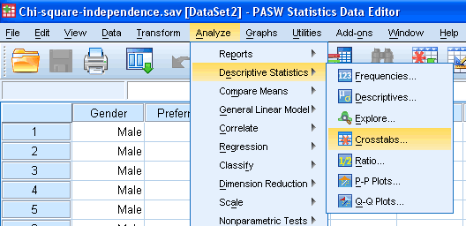
Published with written permission from SPSS Inc, an IBM Company.
- You will be presented with the following:
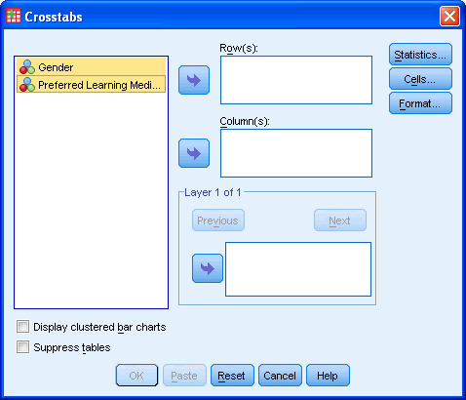
Published with written permission from SPSS Inc, an IBM Company.
- Transfer one of the variables into the "Row(s):" box and the other variable into the "Column(s):" box. In our example we will transfer the "Gender" variable into the "Row(s):" box and "Preferred_Learning" into the "Column(s):" box. There are two ways to do this. You can highlight the variable with your mouse and then use the relevant buttons to transfer the variables or you can drag-and-drop the variables. How do you know which variable goes in the row or column box? There is no right or wrong way. It will depend on how you want to present your data.
If you want to display clustered bar charts (recommended) then make sure that "Display clustered bar charts" checkbox is ticked.
You will end up with a screen similar to the one below:
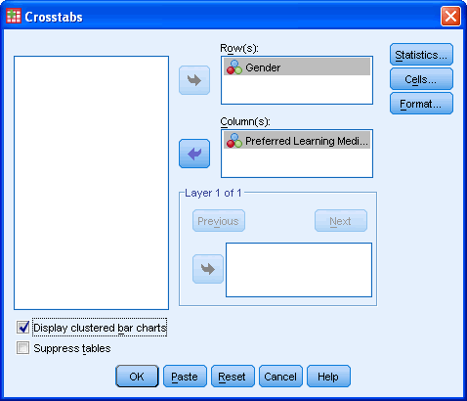
Published with written permission from SPSS Inc, an IBM Company.
- Click on the button. Select the "Chi-square" and "Phi and Cramer's V" options as shown below:
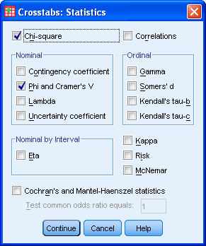
Published with written permission from SPSS Inc, an IBM Company.
Click the button.
- Click the button. Select "Observed" from the "Counts" area and "Row", "Column" and "Total" from the "Percentages" area as shown below:
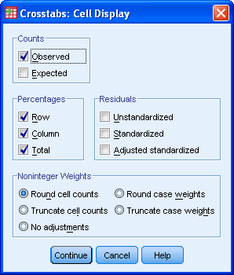
Published with written permission from SPSS Inc, an IBM Company.
Click the button.
- Click the button. [This next option is only really useful if you have more than two categories in one of your variables but we will show it here in case you have]
You will be presented with the following:
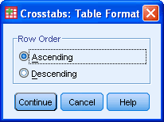
Published with written permission from SPSS Inc, an IBM Company.
This option allows you to change the order of the values to either ascending or descending.
Once you have made your choice click the button.
- Click the button to generate your output.
Output
You will be presented with some tables in the Output Viewer under the title "Crosstabs". The tables of note are presented below:
The Crosstabulation Table (Gender*Preferred Learning Medium Crosstabulation)
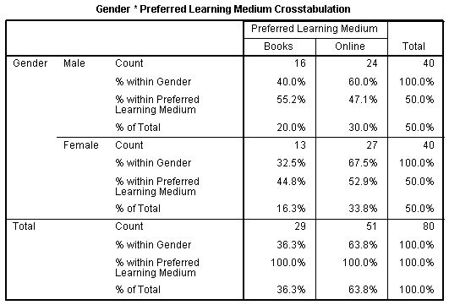
Published with written permission from SPSS Inc, an IBM Company.
This table allows us to understand that both males and females prefer to learn using online materials vs. books.
The Chi-Square Tests Table
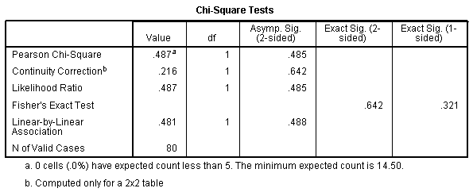
Published with written permission from SPSS Inc, an IBM Company.
When readings this table we are interested in the results for the Continuity correction. We can see here that Chi-square(1) = 0.487, P = 0.485. This tells us that there is no statistically significant association between Gender and Preferred Learning Medium. That is, both Males and Females equally prefer online learning vs. books. If you had a 2 x 2 contingency table and small numbers then ......
The Symmetric Measures Table
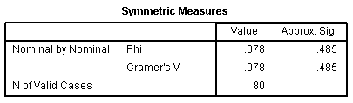
Published with written permission from SPSS Inc, an IBM Company.
Phi and Cramer's V are both tests of the strength of association. We can see that the strength of association between the variables is very weak.
Bar chart
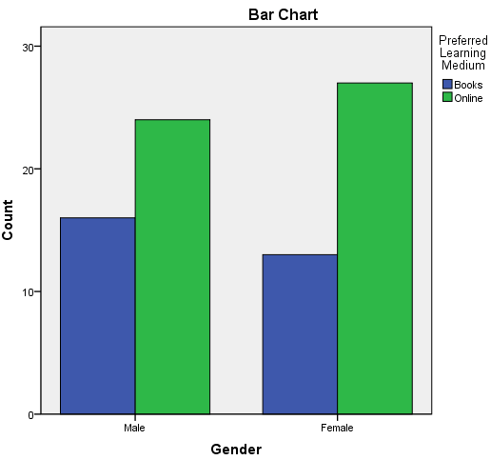
Published with written permission from SPSS Inc, an IBM Company.
It can be easier to visualize data than read tables. The clustered bar chart option allows a relevant graph to be produced that highlights the group categories and the frequency of counts in these groups.

