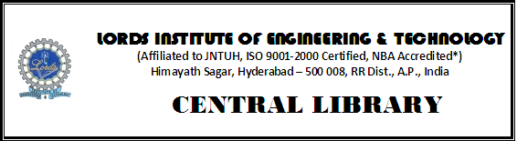
Library Sessions Attendance Statement
Date: Year/Branch/Sec: Day:
S.No | Roll No. | Name of the Student | Resources referred | Sign of the Student | Remarks

LIBRARIAN Faculty In-Charge CONVENER

